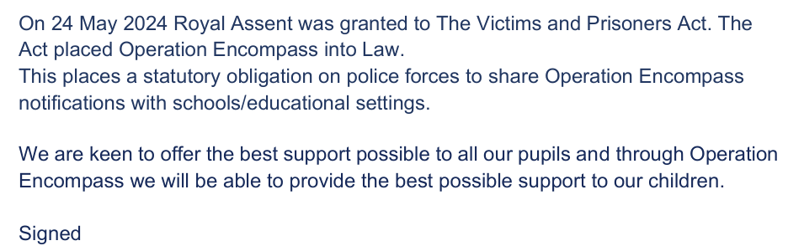
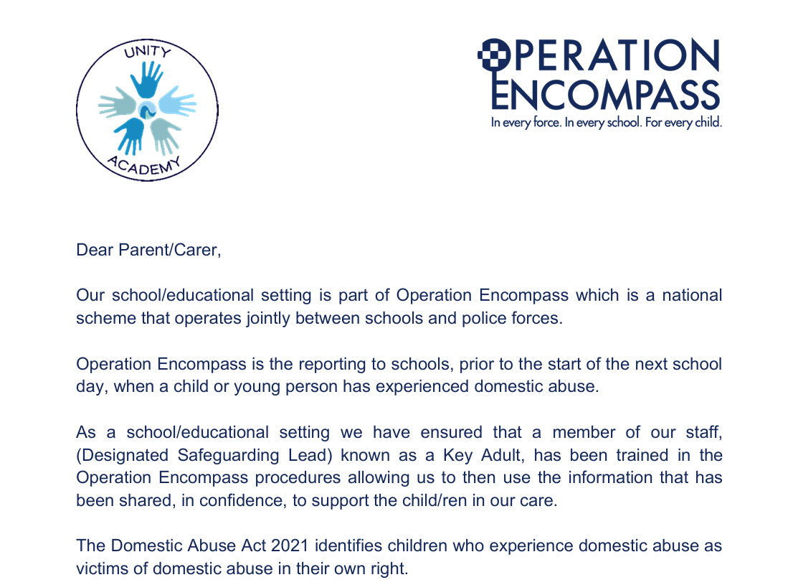

Mrs Dobson
Designated Safeguarding Lead for Unity

